Image result for blank facebook profile picture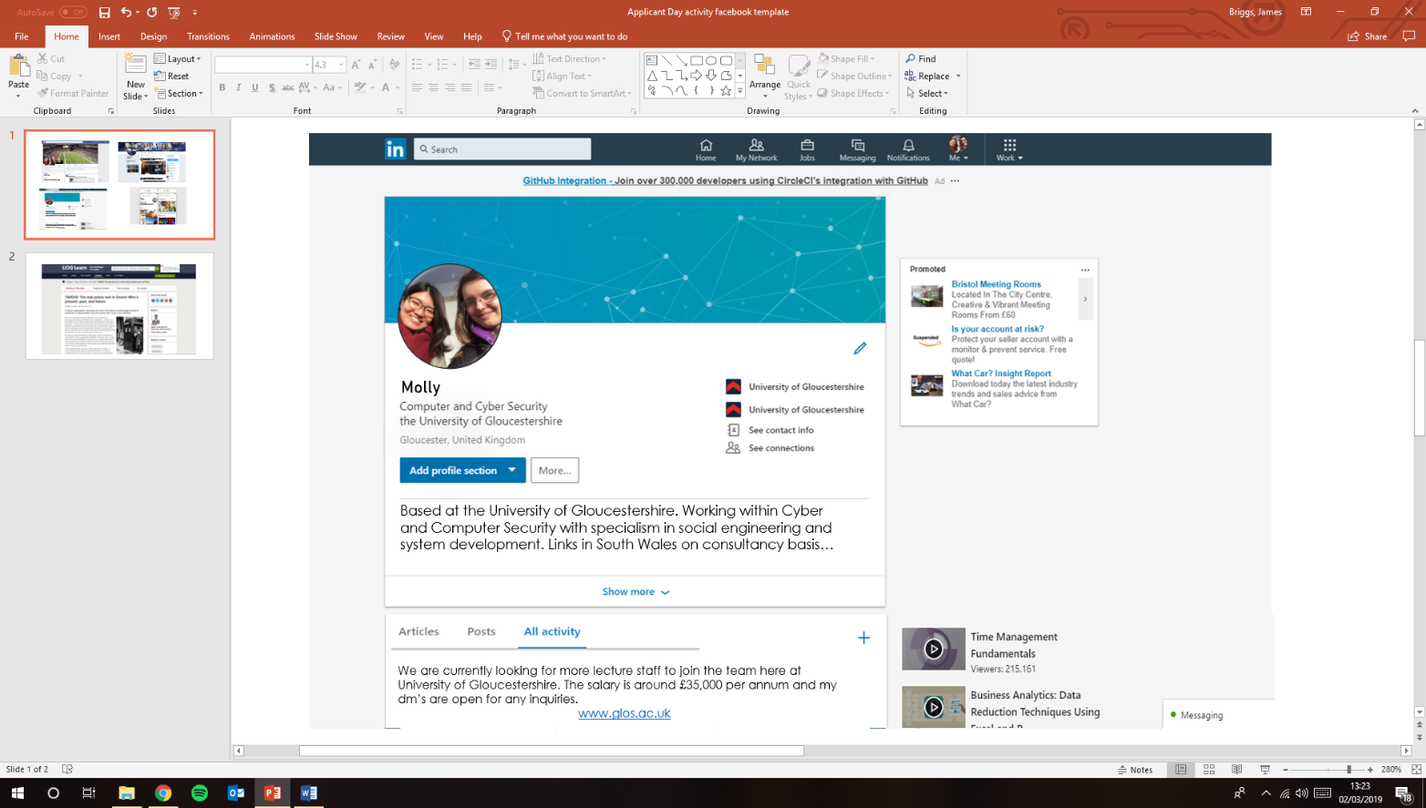Image result for blank facebook profile picture

**Margaret**

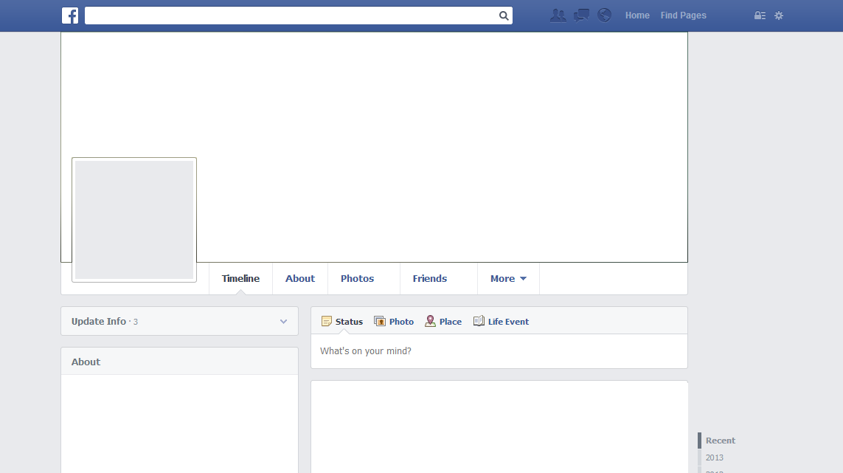

Works at:

UNI OF GLOS

Lives in:

Ebbw Vale, Blaenau Gwent, Wales.

Margaret

February 3rd at 19:12 PM

Very happy with this year’s NFL Superbowl result!

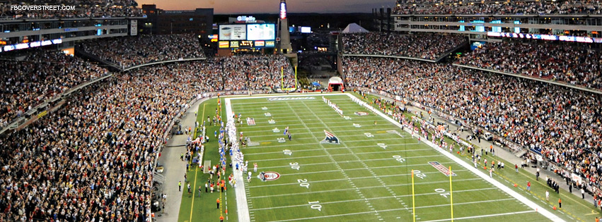

**Margaret**

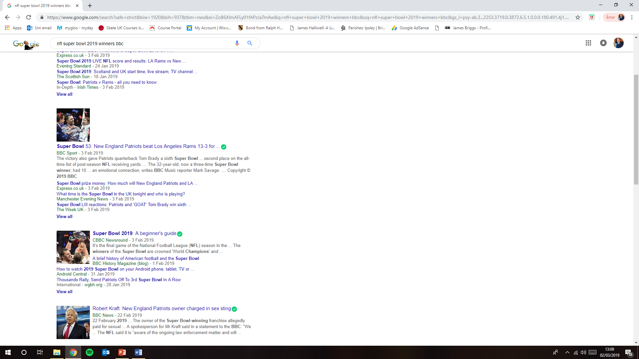

Send

Attach

To:

Subject:

From:



